- Listen to the audio file uploaded today in Classroom (Explicación Blarney Pilgrim), and read the following notes.
IRISH FOLK
The score we are working with is a traditional Irish folk song. The musical form is a jig (giga in Spanish), and is one of the most used compositions in Irish folk (like the ‘’muiñeira’’ in Galicia). And, just like ‘’muiñeira’’, the jig is quite connected with dance.
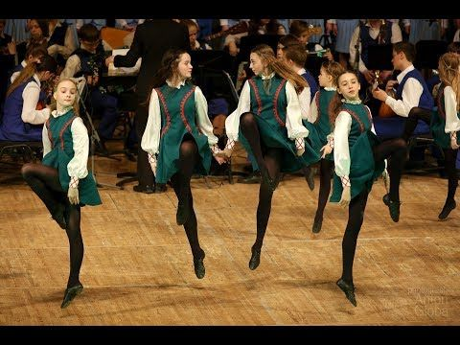
The origin of this dance was in XVIC., in England, and it was spread all along Europe. It was a courtly dance, like minuet. Now a days, jig is commonly associated with Irish and Scottish folk.
Watch the following video:
https://www.youtube.com/watch?v=h_zITCpSNBE
- Hum the score
- Play the rhythm with a percussion instrument
- Research in internet and find 3 Irish folk instruments

