Music activity, 6th May. 3rd ESO.
- Listen to this audition:
https://www.youtube.com/watch?v=8ftsFsScFbM
- Using the next score, try to identify the main characteristics of Gregorian Chant:

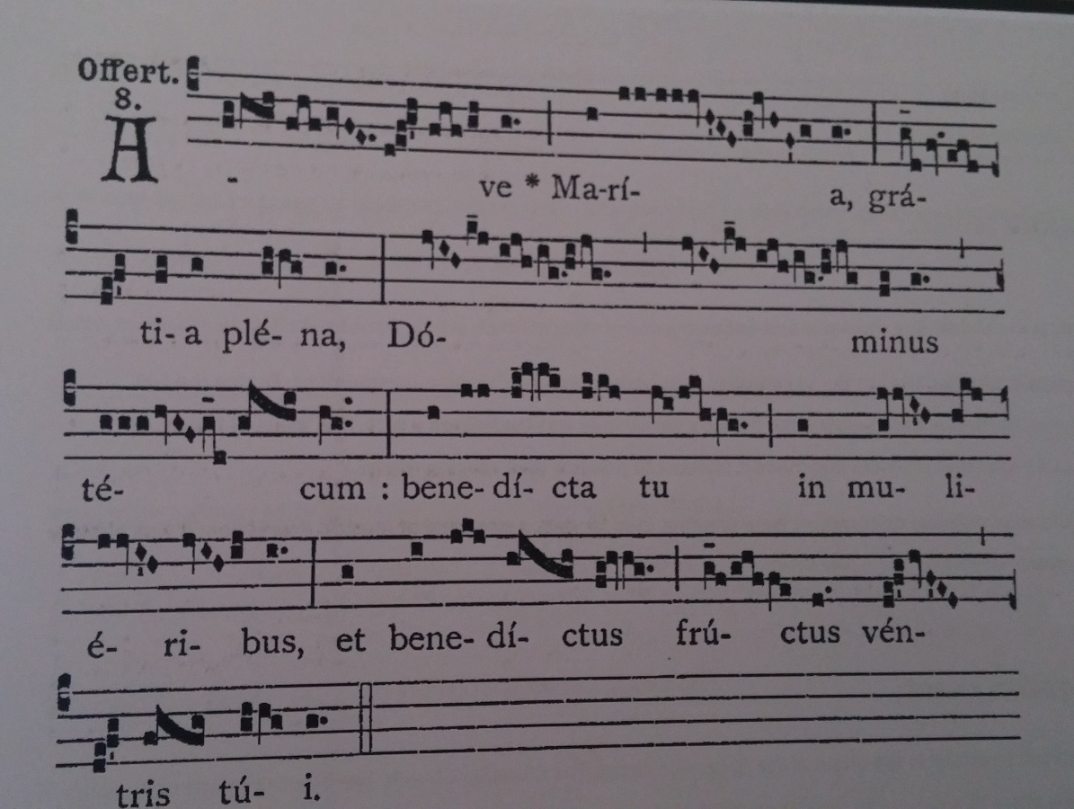

- Listen to this audition. Which difference do you find between this composition and the previous one?
https://www.youtube.com/watch?v=dcfPr4IN2MM (Machaut, Ma fin est mon comencement)

