Music activity 6th May, 2nd ESO
- Read page 13 in unit 2, ‘’singing groups’’:

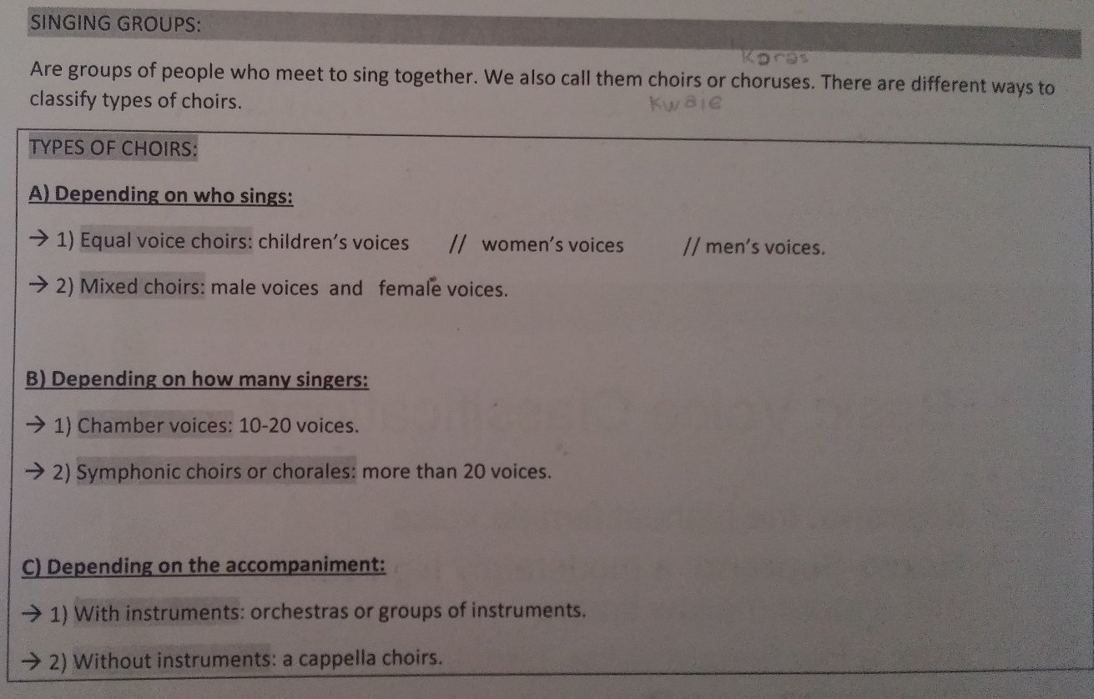
- Watch the following videos and explain which kind of singing group are they:
- https://www.youtube.com/watch?v=mPbjfIf1AeQ (De vacas, De noite e de día)
- https://www.youtube.com/watch?v=GadoE0hO2jY (Pitch perfect, The riff-off)

