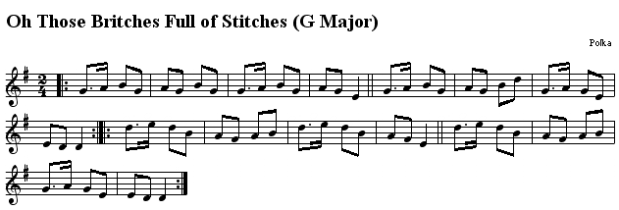
This is the last score we are going to play this school year. It’s also a traditional Irish song, and the musical form is polka.
Polka is a traditional Czech genre of dance music which started in the 19C. After that, it was spread all over Europe, and it arrived to Ireland.
In contrast with other musical forms (like jig or muiñeira) the rhythm is 2/4.
- Watch this video of an Irish folk music band playing the song: https://www.youtube.com/watch?v=1iyfy--v1Mg
- Listen to the Classroom audio file: ´´Explicación Those britches full of stitches’’.
- Write the name of the notes and hum the score

